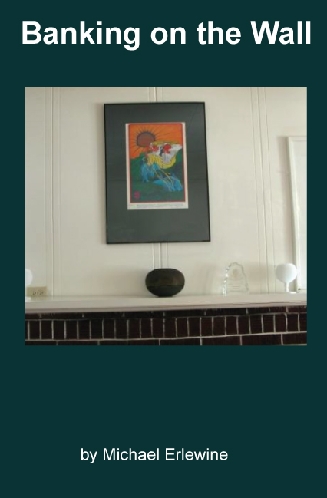Banking on the Wall

by

Michael Erlewine

INTRODUCTION

This is not intended to be a finely produced book, but rather a readable document for those who are interested in in this series on concert poster artists and graphic design. Some of these articles still need work.

Michael@Erlewine.net

Here are some other links to more books, articles, and videos on these topics:

Main Browsing Site:

<http://SpiritGrooves>.net/

Organized Article Archive:

<http://MichaelErlewine>.com/

YouTube Videos

<https://www.youtube.com/user/merlewine>

Spirit Grooves / Dharma Grooves

Copyright © Michael Erlewine

You are free to share these blogs  
 provided no money is charged

**Banking On the Wall**

by Michael Erlewine (Michael@Erlewine.net)

**Posters Around the House**

Concert-music posters are informal and can be put up almost anywhere, in the home or at the business

At some point, I decided to take down the Klee prints, the O'Keefe, and the little batiks we had picked up at the flea markets and replace them, at least in some rooms, with rock and roll art - concert music posters. For one, I had to have some of the concert posters that I had designed and printed for my own band, back in the sixties, on the wall.



**My Own Posters**

I think that this Bob Fried piece, another favorite of mine, looks great over the fireplace, too.



**Canned Heat poster by Bob Fried**

And of course, the music room would not really be cool without at least a touch of Woodstock, at least for an old hippie like myself.



**Woodstock**

Well, Perhaps not Palaces Yet



**Well, perhaps palaces are not ready for concert posters**

My house happens to be pretty funky, but many of these posters are just elegant and look right at home in more elegant settings. True, you have to be just a little daring to do it, but who is looking, anyway? Who cares what we do in our own home? The two photos below give you some idea of how posters could look in what we might agree are very elegant homes.



**A Moscoso Adds a Touch of Elegance**



**A Collage from David Singer on the Wall**



**Get Them on the Wall**



**Viewing**

**Posters in Business**

When I decorated the new headquarters of AMG (the All-Music Guide), when we moved it to Ann Arbor, I bought hundreds of posters and had them matted and framed. They lined the halls and meeting rooms and looked just great, everything from Boss Hog to Bob Dylan.



**Posters Liven up Businesses**

While I tend to be pretty sparing as to how many posters I want to put on any given wall, this is not always the most successful approach. Many folks like to fill every available space with posters and they look pretty great at that. Here are three views of San Francisco's S.F. Rock, one of the main stores for posters on the West Coast. As you can see, the walls are filled, but it is all very tastefully and effectively done. There is a lot to see.